Your name Vera Zhukouskaya Date 11.03.2021

**Good luck!**

**Introduction to the project:**

|  |  |
| --- | --- |
| Imagine that you are assigned to a new project as a tester.  Testing team: you and test team lead Mike.  This is a small mobile project for iOS.  “Canteen menu” application is developed for a huge company located all over the world. Application is targeted on company’s canteens stuff. It will be used for week menu management (creation, edition, etc).  Canteen employees are equipped with iPads or iPhones X.  After login to the application user (canteen employee) is redirected to “Menu List” screen with the list of menus for different company’s canteens (in different locations), “Country”, “City”, “Canteen” filters.  **New feature “Menu Editor” will be implemented during the upcoming iteration.**  Your task is:   1. Review the requirements for the new feature provided by BA Barbara 2. In case of any questions you have to write email to Barbara with request to clarify your questions 3. Provide estimations for test activities for this feature by email to your test lead Mike 4. Write test cases for the feature 5. Review provided screens with the implemented feature 6. Find and submit bugs in case of any 7. Send test results and your decision about quality of the feature to Mike (\*optional)   **Below you will find requirements for the feature and templates for emails, test cases, bug reports, etc. Please fill in only those templates that you think reasonable in scope of this feature. You can write any additional information if required.** | E:\lectures\Test 3\1.png |
| **Requirements for the new feature:**  AS an administrator  I CAN **create menu**:   1. I am in “Menu List” screen 2. I click “create” button - “Menu Editor” screen opens 3. I type canteen name in “Menu name” field 4. I choose canteen from list and click it 5. I select “To” date from date picker 6. I select “From” date from date picker 7. I click “save” button – “Menu List” screen opens, new menu is added to the list | E:\lectures\Test 3\2crop.png |
| AS an administrator  I CAN **edit menu**:   1. I am in “Menu List” screen 2. I click edit icon C:\Users\Lidziya_Smirnova\Desktop\Icons\89031-200.png - “Menu Editor” screen opens 3. From the dates panel I choose date I want to add dish offers to 4. In dish categories list I choose category I want to add dish offers to 5. If there are no dishes in the category – empty field is displayed 6. If the number of dishes exceeds the screen – the list can be scrolled 7. I can remove dish from the list 8. “Add dish” feature will be implemented later | |
| E:\lectures\Test 3\2.png | E:\lectures\Test 3\2a.png |

**Clarification letter to BA regarding new feature:**

|  |  |
| --- | --- |
| **To:** | Barbara Smith |
| **CC:** | Mike |
| **Subject:** | “Canteen menu”: requirements for the new feature ‘AS an administrator I can create/edit menu’ |
| Hello Barbara,  My name is Vera Zhukouskaya, junior QA tester in our project “Canteen menu”.  For upcoming iteration with new feature ‘AS an administrator I can create/edit menu’ -  Could you please answer the next questions?  1. What is the confirmation after user registration?  2. Are the filter lists ‘country’, ‘city’, ‘canteen’ depends on each other (‘city’/ ‘canteen’ have only options from chosen country/city)?  3. Should a user make some choice by country, city and canteen for creating a “Menu List” before clicking “create” button?  4. There is one more filter list ‘canteen’ in “Menu editor” by creating a menu. What is the relationship between filter ‘canteen’ in “Menu editor” and ‘canteen’ in “Menu List”?  5. When creating new menu in requirements in step #3 a user should write canteen name in ‘menu name’ field and also we have filter ‘canteen’ is located below. Is there any difference between canteen in ‘menu name’ and canteen filter ‘canteen’?  6. Will the “Add dish” feature will be implemented at the beginning of the next iteration?  Please send the requirements and layout for adding new fish.  Thanks in advance,  Vera Zhukouskaya  QA tester “Company”  Email: [verisola@gmail.com](mailto:verisola@gmail.com)  mobile: +375 29 111 11 11 | |

**Test estimations for new feature to Test team lead:**

|  |  |
| --- | --- |
| **To:** | Mike |
| **CC:** | Barbara Smith |
| **Subject:** | “Canteen menu” estimations (next iteration) |
| Hello Mike,  I send my questions by email “Canteen menu”: requirements for the new feature ‘AS an administrator I can create/edit menu’”  to Barbara Smith (your email was in copy). And the final estimation will correct according the answers on these questions (may be some more test cases will need us).  Here is my estimation for testing by that moment.  According to our plan, purposes and including the requirements and some risks I сounted that the testing new feature “Menu Editor” will need three hours and a half for one testing engineer.   * 1 tester * 4 TCs – 40 min * Bug reporting, email, meeting – 10% * Risks – 10% * 2 iterations * 2 devices iPads and iPhones X.   40 min\*10%\*10%\*2\*2=193,6 min/60 min=3,22 hours=3,5 hours  Best regard,  Vera Zhukouskaya  QA tester “Company”  Email: [verisola@gmail.com](mailto:verisola@gmail.com)  mobile: +375 29 111 11 11 | |

**Test cases for new feature:**

|  |  |  |  |  |  |  |
| --- | --- | --- | --- | --- | --- | --- |
| **№** | **Req №** | **Module** | **Test Description** | **Expected results** | **Passed/Failed** | **Comments** |
| 1 |  | Menu list | **Check opening ‘Menu List” by log in.**  1. open the app and log in (use the data from the file1 in the attachments) | 1. “Menu List” is opened | passed |  |
| **№** | **Req №** | **Module** | **Test Description** | **Expected results** | **Passed/Failed** | **Comments** |
| 2 |  | Create menu | **Check menu creation.**  Precondition: verify that the app is installed, and ‘Menu List” is opened.  1. click [create] button  2. enter “menu 1” in ‘menu name’ field  3. choose “canteen 1” from the ‘canteen’ list  4. choose the dates from 07.08.2017 to 11.08. 2017  5. click [save] button | 1. “menu editor” is opened  2. “menu 1” in ‘menu name’ field  3. “canteen 1” is in the ‘canteen’ list  4. the dates from 11.03.2021 to 17.03. 2021 are set up  5. “Menu List” screen opens, new menu 1 is added to the list | passed |  |
| **№** | **Req №** | **Module** | **Test Description** | **Expected results** | **Passed/Failed** | **Comments** |
| 3 |  | Edit menu | **Check removing dish.**  Precondition: open “Menu List”  1. click edit icon  2. choose date 09.08.2017 Wednesday  3. | 1. “Menu Editor” screen is opened  2. date 09.08.2017 Monday has blue color and there is cream soup below  3. the soup field is empty | passed |  |
| **№** | **Req №** | **Module** | **Test Description** | **Expected results** | **Passed/Failed** | **Comments** |
| 4 |  | Edit menu | **Check adding new dish**.  Precondition: verify there is one menu is added  1. open ‘menu editor’ and choose the date 09.08.2017 Wednesday  2. press [add] button | 1. date 09.08.2017 Monday has blue color and there is cream soup below  2. the dish is added to the menu | failed | TBD |

**“Menu Editor” feature is ready for testing:**

Developers have finished implementation of “Menu Editor” feature. Build with the feature is released and successfully installed.

When editing the menu you see the following screen:

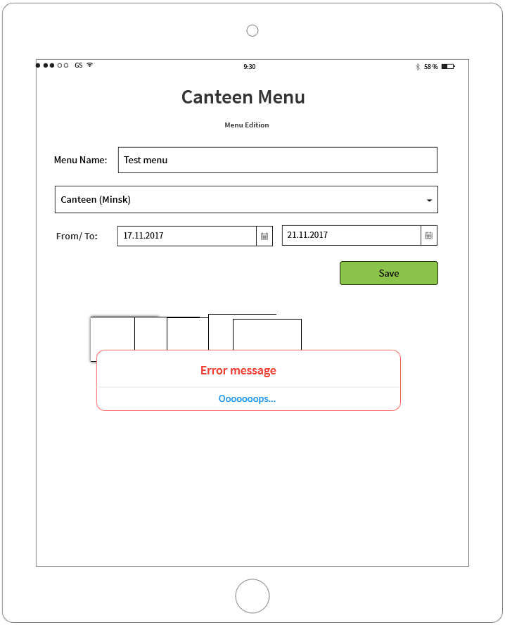

**If you see any bugs in this screen, you can post them below:**

**Bug reports:**

|  |  |
| --- | --- |
| **Bug ID** | **#1** |
| **Summary** | Label ‘To:’ is located to the left of the field ‘From’ |
| **Description** | There are two date field with the labels. And first field ‘From’ has two labels ‘from/to:’ |
| **Severity** | trivial |
| **Steps to reproduce** | Precondition: verify there is min one added menu  1. log in and open ‘menu list’  2. open ‘menu editor’ by clicking edit icon C:\Users\Lidziya_Smirnova\Desktop\Icons\89031-200.png  Actual result:  Graphical user interface  Description automatically generated with medium confidence  Expected result:  Each field has its own label: ‘From:’ for the first one and ‘To:’ for the second one |
| **Bug ID** | **#2** |
| **Summary** | ‘Menu edition’ instead of ‘Menu editor’ |
| **Description** | The window ‘Menu editor’ in Canteen menu has another title ‘Menu edition’ |
| **Severity** | trivial |
| **Steps to reproduce** | Precondition: verify there is min one added menu  1. log in and open ‘menu list’  2. open ‘menu editor’ by clicking edit icon C:\Users\Lidziya_Smirnova\Desktop\Icons\89031-200.png  Actual result: The window has title ‘Menu edition’  Expected result: The window has title ‘Menu editor’ |
| **Bug ID** | **#3** |
| **Summary** | There are error message “Oooooops” instead of the dishes list, dates and add button in opened ‘Menu editor’ |
| **Description** |  |
| **Severity** | critical |
| **Steps to reproduce** | Precondition: verify there is min one added menu  1. log in and open ‘menu list’  2. open ‘menu editor’ by clicking edit icon C:\Users\Lidziya_Smirnova\Desktop\Icons\89031-200.png  Actual result:  Diagram  Description automatically generated  Expected result: ‘menu editor’ is fully loaded  Diagram  Description automatically generated |

**Test result report to Test team lead:**

|  |  |
| --- | --- |
| **To:** | Mike |
| **CC:** | Barbara Smith |
| **Subject:** | “Canteen menu” test result 11.03.2021 |
| Hello Mike,  Today I’ve wrote 4 TCs (file in the attachments) and run them on iPhones X.  Found bugs you can see in Jira Project…. New feature “Add dish” is failed (Bug #3).  I got the answer from Barbara Smith, so I can continue writing TCs while the engineer is fixing Bug #3  At the moment the app quality is rather middle. User can: log in, create menu, choose a dish (but the list is small) and remove a dish. After fixing bug #3 the functional will be full, and I’ll do retest bug #3 and regression testing according our TCs.  See you on evening meeting.  Best regard,  Vera Zhukouskaya  QA tester “Company”  Email: [verisola@gmail.com](mailto:verisola@gmail.com)  mobile: +375 29 111 11 11 | |

**Thank you!**